The Southern Sandoval County Arroyo Flood Control Authority is pleased to announce the Ribbon Cutting Ceremony for the Lower Montoyas Water Quality Feature Project.

The Lower Montoyas Water Quality Feature will help remove sediment which has historically increased the risk of flooding at the Corrales Road crossing of the Harvey Jones Channel and provide an attractive open space area for the local community.

This project incorporates a number of “green build” and Low Impact Development (LID) concepts to provide a functional flood control facility that enhances the environment.  The project will keep the arroyo channel in a natural state with minimal traditional hardened elements; this will allow natural infiltration of storm flows to assist in recharging our aquifers and promoting the growth of local native vegetation and preservation of habitat for local wildlife.

Plants have been added as an integral part of water quality and grade control structures to add a “living screen” to assist in removing debris from storm water before it enters the hard lined Harvey Jones Channel.  These plants will be irrigated for two years to ensure a robust plant colony is established.

This project was made possible through the Environmental Protection Agency Clean Water State Revolving Loan Fund.

Please join us in celebrating this innovative

flood control solution!

**When**: June 2, 2016 at 10:00 a.m.

**Where**: Don Julio Road (Cul de Sac), Corrales, NM

*Facility designed by:*

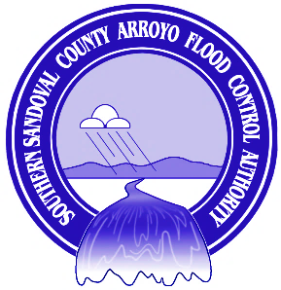

***Southern Sandoval County   
Arroyo Flood Control Authority***

**1041 Commercial Drive SE • Rio Rancho, NM 87124  
Ph (505) 892-RAIN (7246) • Fax (505) 892-7241**

**www.sscafca.com**

**BOARD OF DIRECTORS**  
John Chaney  
Mark Conkling  
James F. Fahey Jr.   
Steven M. House  
Michael Obrey

**EXECUTIVE ENGINEER**

Charles Thomas, P.E.

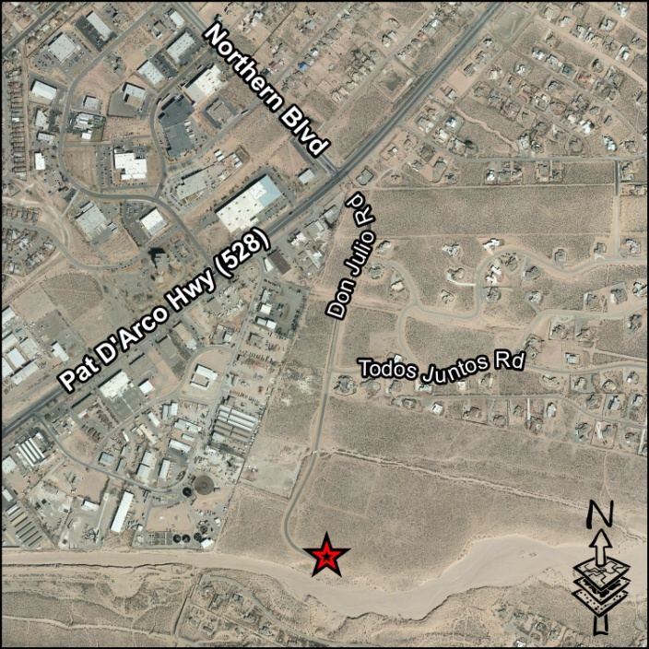

[Home](http://www.wilsonco.com/)